How to find us
Prime City Centre Location
i2 Office
99 Bishopsgate
London, EC2M 3XD
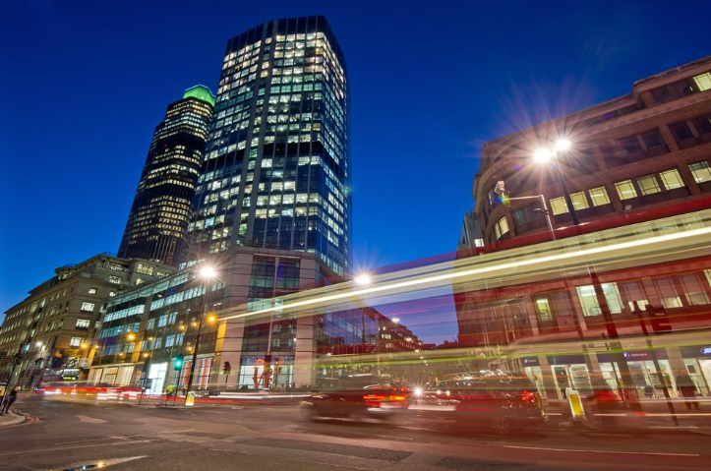

From the train station Liverpool Street Station EC2M 7QH
Upon leaving the underground look for the Bishopsgate exit. To your right from Hammersmith and City and Cycle lines or turn left from leaving Central line
Turn right upon entering Bishopsgate turn Right - Carry on straight for 200M staying on the right hand side.
Cross over Wormwood Road and we are 2nd on the right handside.

Bus station 99 Bishopsgate
There is a bus station outside the front of 99 Bishopsgate. All bus numbers below will drop you to 99 Bishopsgate.
8; 11; 21; 23; 25; 26; 35; 43; 47; 48; 76; 133; 141; 149; 242; 344; 388.
All buses are at a 3 minute interval.

Car parking options Bishopsgate
London Wall Corporation of London- 23 London Wall, London, EC2V 5DY (closest parking to 99 Bishopsgate)- Motor Cycles park for free. Alternatively NCP has numinous location nearby
Travelling via Car
Bishopsgate provides a direct link to the south via London Bridge and the A3. It is also possible to cross to the south side of the river via Southwark Bridge (A300).
Routes east are via the A13 and the A12, which leads to the M11.
The A13 allows for easy access to the A2 via the Blackwall Tunnel.
Parking is heavily restricted in the general area. However, public car parks are available in the local vicinities and there is some meter parking available in nearby streets. Motor cycle parking areas are also available nearby.
The building is within the London Congestion Charge area

The major train stations
All train stations are accessible by London underground services. Please refer to TFL
Kings Cross St Pancras International - Connections to Luton and Gatwick airport
Victoria – Connections to Gatwick
Paddington- Connections to Heathrow
London Bridge – National South West services.

Taxi
Taxis can be booked via reception. Alternatively black cabs are operational throughout the city.

