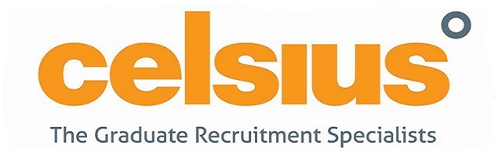
To achieve this prestigious Diploma you must complete 6 of the courses listed below within a 12 month window. The courses will be held in both Manchester and Central London and the 6 modules are offered at an introductory price of £1,995 per person. Please can you tick and return the table below indicating which 6 modules you wish to attend, and your preference for location. We will then forward the calendar and get your place reserved.
Course Name | Preferred location: Manchester | Preferred location:  London
High Impact Presenting
Transition to Field Sales
Time Management
Maximising Social Media
Major Account Sales
Leadership & Management Skills
Change2achieve
Live Telephone Coaching
Closing the Sale
Advanced Telephone Selling
Advanced Selling Skills
Protection, Retention & Development of Accounts

